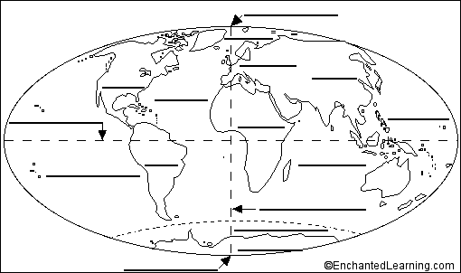

Arctic Ocean  Atlantic Ocean  Indian Ocean  Pacific Ocean  Southern Ocean | Africa  Antarctica  Asia  Oceania | Europe  North America  South America | Equator  North Pole  South Pole  Prime Meridian

